**AGILE MODEL**

In traditional software development methodologies like Waterfall model, a project can take several months or years to complete and the customer may not get to see the end product until the completion of the project.

But here in **Agile** projects we have [**Sprints or iterations**](http://istqbexamcertification.com/what-is-sprint-planning-in-agile-project-management/) which are shorter in duration (Sprints/iterations can vary from 2 weeks to 2 months) during which pre-determined features are developed and delivered.

The Agile model can be explained with the help of below image,

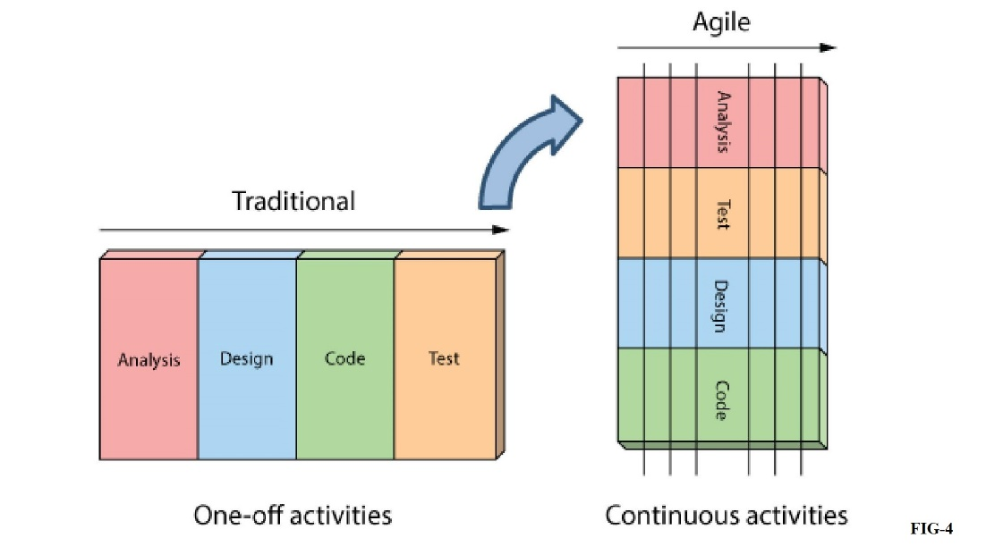

**In the above image we can see that only certain features or modules are released with all kind of tests. Instead of doing all test and other work at a time as we will do in case of Waterfall model we will split the releases here.**

Agile projects can have one or more iterations and deliver the complete product at the end of the final iteration.

Let us understand better with an example as below,

In traditional **Waterfall model** –

* At a high level, the project teams would spend 15% of their time on gathering requirements and analysis (1.5 months)
* 20% of their time on design (2 months)
* 40% on coding (4 months) and unit testing
* 20% on System and Integration testing (2 months).
* At the end of this cycle, the project may also have 2 weeks of User Acceptance testing by marketing teams.
* In this approach, the customer does not get to see the end product until the end of the project, when it becomes too late to make significant changes.

The image below shows how these activities align with the project schedule in traditional software development.

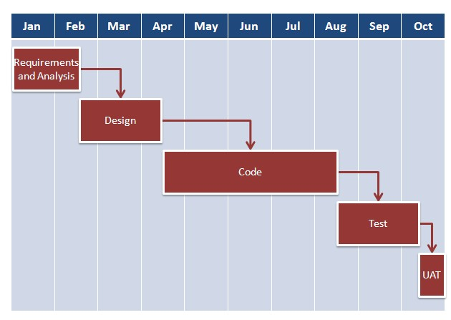

With **Agile development** methodology –

* In the [**Agile methodology**](http://istqbexamcertification.com/what-is-agile-methodology-examples-when-to-use-it-advantages-and-disadvantages/), each project is broken up into several ‘Iterations’.
* All Iterations should be of the same time duration (between 2 to 8 weeks).
* At the end of each iteration, a working product should be delivered.
* In simple terms, in the Agile approach the project will be broken up into 10 releases (assuming each iteration is set to last 4 weeks).
* Rather than spending 1.5 months on requirements gathering, in Agile software development, the team will decide the basic core features that are required in the product and decide which of these features can be developed in the first iteration.
* Any remaining features that cannot be delivered in the first iteration will be taken up in the next iteration or subsequent iterations, based on priority.
* At the end of the first iterations, the team will deliver a working software with the features that were finalized for that iteration.
* There will be 10 iterations and at the end of each iteration the customer is delivered a working software that is incrementally enhanced and updated with the features that were shortlisted for that iteration.

The iteration cycle of an Agile project is shown in the images below.

